



**TUGAS**

**ANALISIS QOS LALU LINTAS JARINGAN KOMPUTER**

**KOMUNIKASI DATA**

**MUHAMMAD ADI NUGROHO**

**FASILKOM**

**SISTEM KOMPUTER**

**SK4B INDRALAYA**

**09011282025066**

**Quality of Service**

Summary hasil capture Wireshark

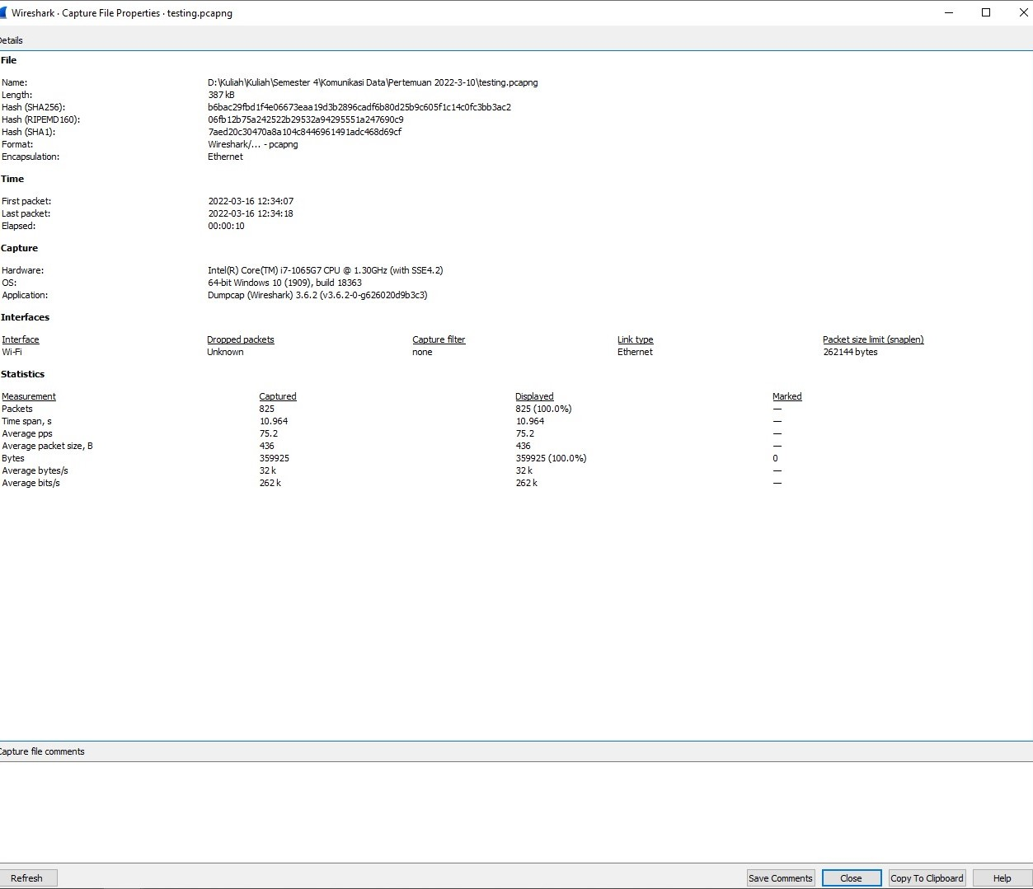

website yang dikunjungi saat analisis lalu lintas jaringan komputer: <https://www.rendiriansyah.com/2020/06/cara-mengukur-dan-menghitung-delay.html>

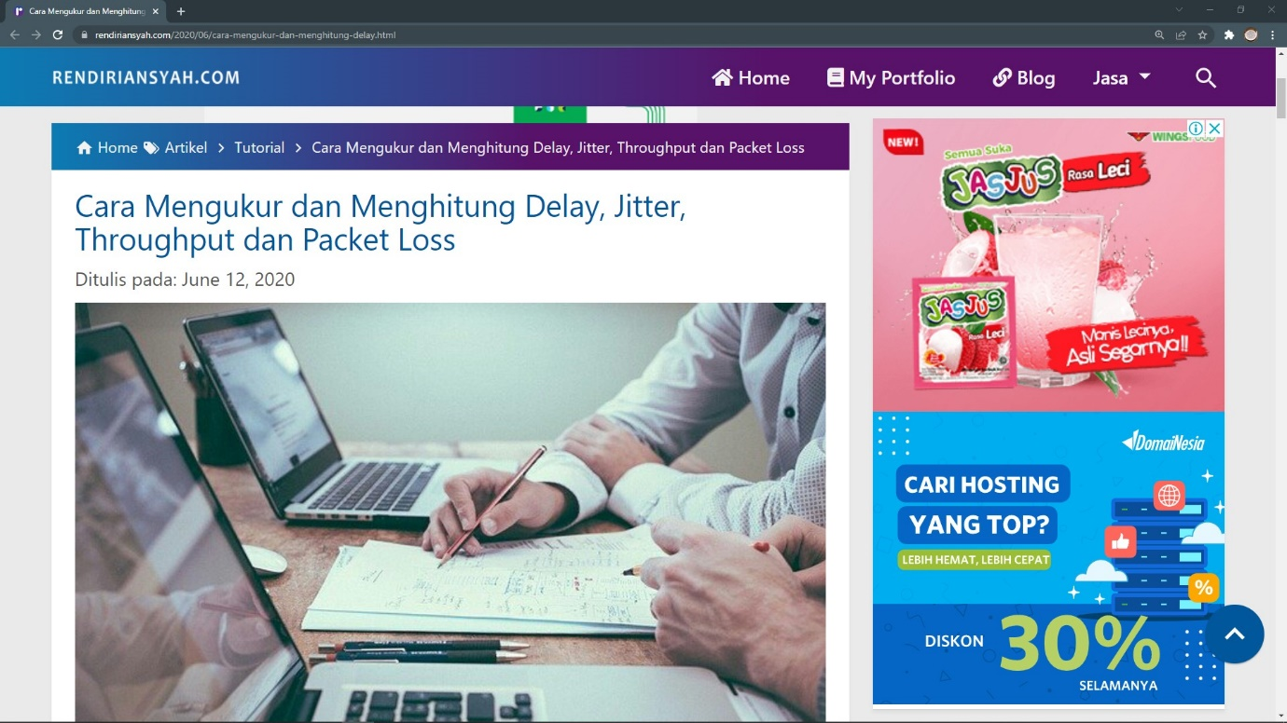

- Delay

Rata-rata delay = Total delay / Total paket yang diterima

= 10.964 sec / 825

= 0.0132896969696969696969696969697 sec

= 13.289696969696969696969696969697 ms

- Jitter

Rata-rata jitter = Total variasi delay (total jitter) / (Total paket yang diterima - 1)

= 0.060681 sec / (825 - 1)

= 0.060681 sec / 824

= 0.000073641990291262135922330097087379 sec

= 0.07364199029126213592233009708738 ms

- Throughput

Throughput = Paket data yang diterima / lama pengamatan

= 359925 bytes / 10.954 sec

= 32827.891280554542137905873768698 bytes

= 32.827891280554542137905873768698 kb

- Packet Loss

Packet Loss = ( (Paket data dikirim - paket data diterima) * 100% ) / paket data yang dikirim

= ( (825 - 825) * 100 % ) / 825

= ( 0 * 100 % ) / 825

= 0 % / 825

= 0 %

File .csv dan .pcapng berada di link GitHub berikut

<https://github.com/Adi-sys/Analisis-QOS.git>